Date: 24 Aug. 2011
Spec. No.: PP80221
Fire Resistant Instrumentation Cable
Application

These cables are fire resistant, flame retardant, low smoke, halogen free and oil resistant, used for instrumentation, communication, control and alarm systems.
Standard
BS6883
IEC 60092 IEC60331-21

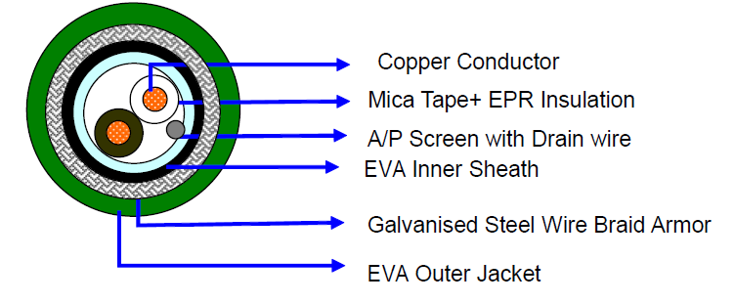
Construction
Conductor: Stranded Copper Conductor to BS6360
Insulation: Mica tape+EPR Complying with BS7655 GP4
Nominal Thickness: 0.6mm
Overall screen: Aluminium/ p.e.t.p. Laminated tape applied with the metallic side down in electrical contact with 20 AWG, 0.5mmsq tinned copper drain wire.
Bedding: EVA
Nominal Thickness: 1.1mm

Armor: Galvanised Steel Wire Braid
Sheathing: EVA
Nominal Thickness: 1.2mm
Sheath Color: Green or upon request
Packing: The cables are delivered on non-returnable wooden drums.

Physical Properties
Temperature rating: -20 to +90℃
Minimum bending radius: 8 x Overall Diameter
Fire resistant: IEC60331
Flame retardant: IEC60332 -3

Dimensional Data
Conductor | Number of Pairs | Approx Nominal Dia under Armour  (mm) | Approx Nominal Overall Dia  (mm) | Armour Wire  Dia  (mm) | Approx Weight  (kg/km)
1.5mmsq  (7/0.53mm) | 1 | 10 | 13.5 | 0.3 | 245
1.0mmsq  (7/0.43mm) | 2 | 12 | 16 | 0.3 | 260

Electrical Data

Conductor Area size | 1.5 | 1
Rated voltage | 250V | 250V
Nom. Inductance | 40 μH/ohm | 25 μH/ohm
Nom. conductor resistance at 20 ℃ | ≤12.9 Ohm/Km | ≤18.2 Ohm/Km
Maximum Mutual capacitance | 85pF/ m | 75pF/ m

